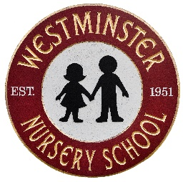

Kindergarten Supply List

- standard sized book bag (no wheels)
- lunchbox
- 3 pocket folders with bottom pockets
- 3 boxes of crayons (no bigger than 16 count)
- 1 - 4 oz. bottle of liquid glue
- 2 dry erase markers
- 1 package of markers (not permanent, not fine tip)
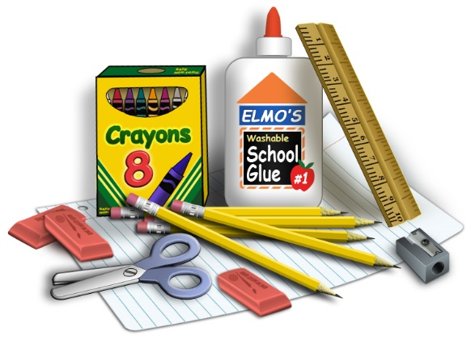
- blunt tip scissors
- 4 glue sticks
- art smock

Please clearly label all supply items with your child’s name.

